How to create and delegate Active Templates.

Active templates allow administrators to quickly create and manage sets of permissions to apply to objects in Active Directory. Any changes made to security using active templates can be repaired or removed. Custom templates can be made and standardized easily.

To create an active template, click Security & Delegation | Active Templates and then click “New”.

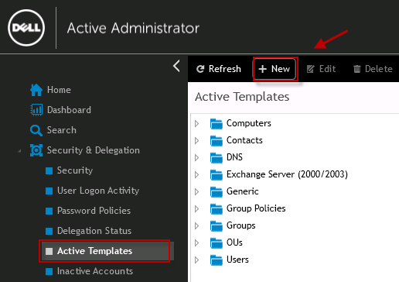

On the wizard welcome page, click “Next”.

Set the name, category and description for the new Active Template, and then click “Next”.

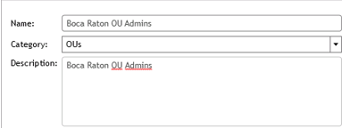

Select the permissions for the new Active Template:
- From the “Forest” list, choose a domain.
- From the “Applies to” list, choose how apply the template security. Select common object types, all object types on the system, or an inheritance level.
- From the “Classes” list, select the object.

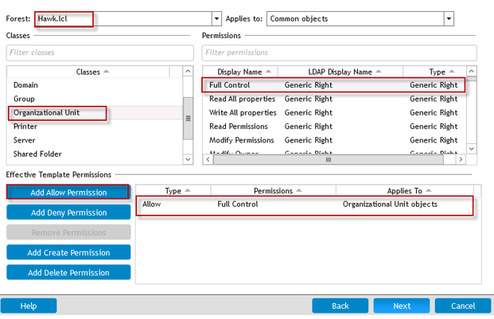

Create a new delegation for the Active Template from the Delegations drop down menu.

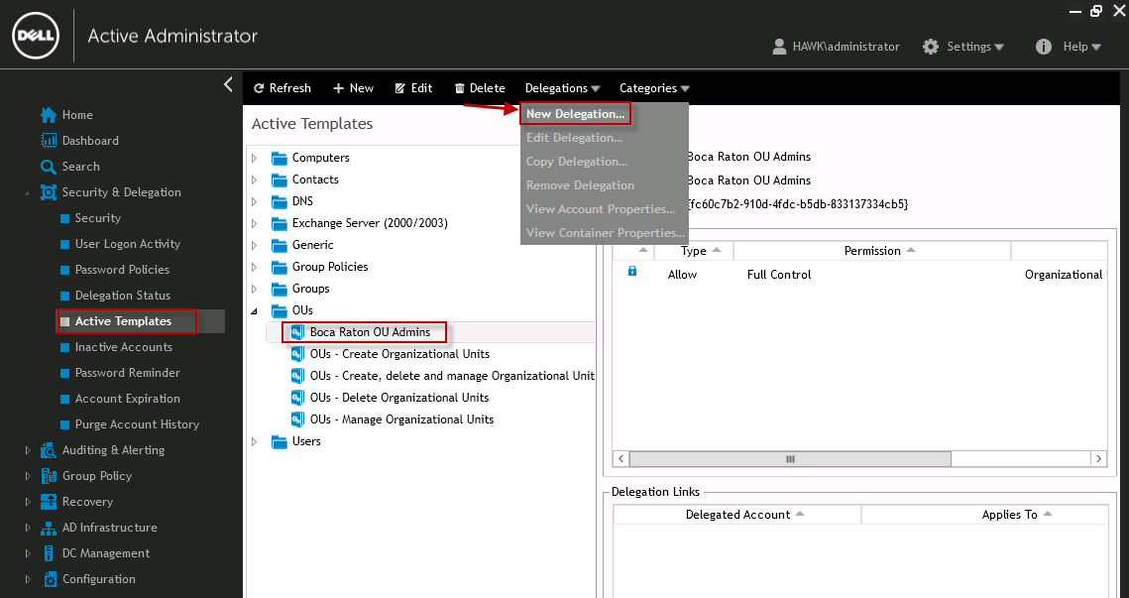

Select the users or groups to apply the delegation to, and then click “Next”.

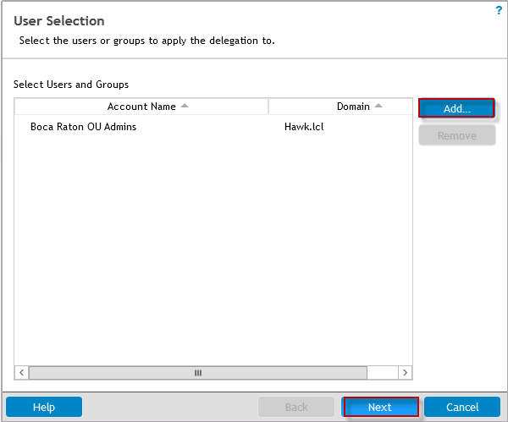

Select the paths or objects to apply the delegation to, and then click “OK”.

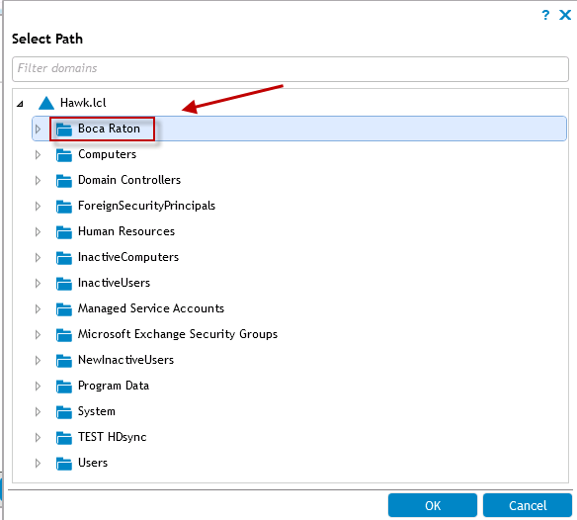

Set the delegation options, and then click “Next”.

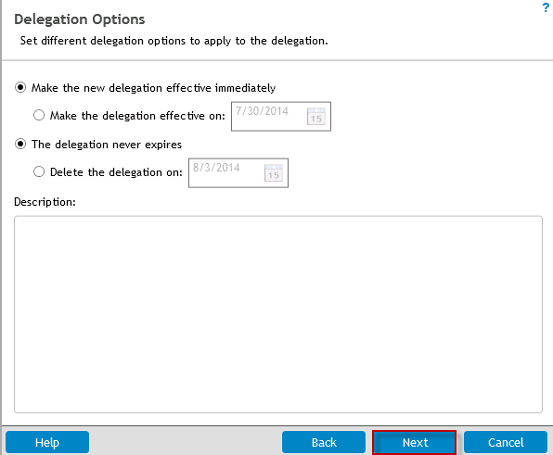

Review the summary details, and click “Finish”.

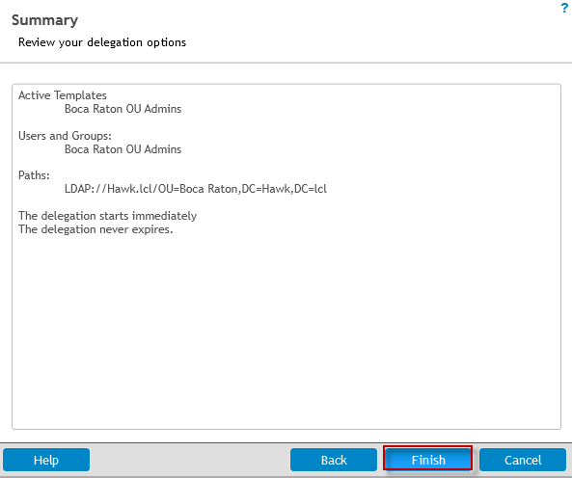

Click “Delegation Status” to view the status.

